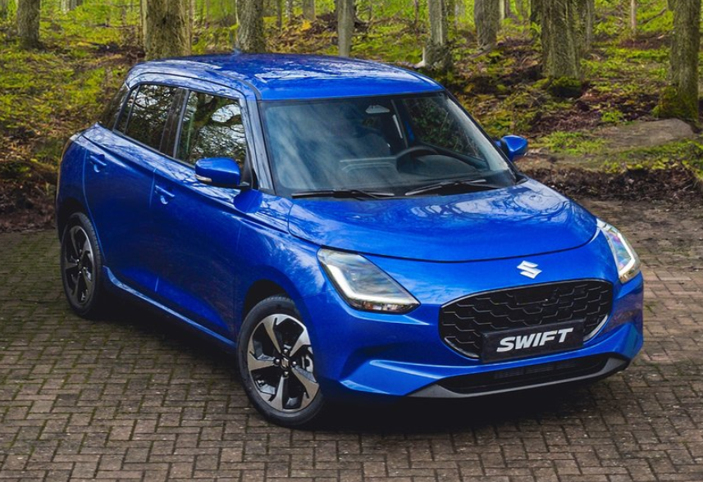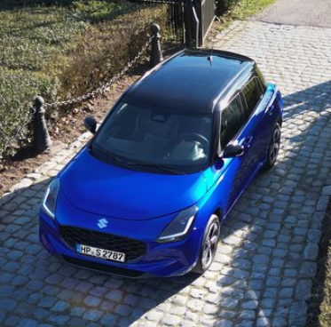

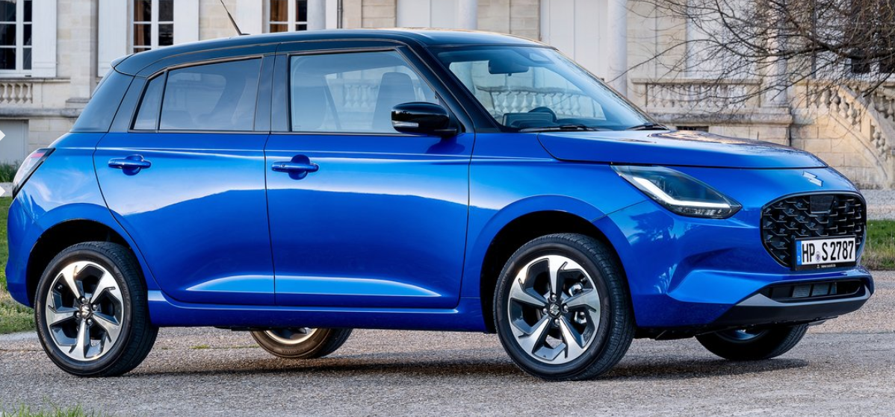

**Main specifications** of the **2024 Suzuki Swift** (fourth-gen), summarized for clarity:

**🔧 Powertrain & Performance**

* **Engine**: 1.2 L inline‑3 petrol (Z12E), 82–83 PS (~80 hp), 108–112 Nm torque @ 4,500–4,200 rpm
* **Drivetrain**: Front-wheel drive, with available mild-hybrid (12 V ISG) or conventional petrol – manual or CVT transmission; AMT in some markets
* **0–62 mph**: ~12.5 s; top speed ~103 mph (~165 km/h)

**⛽ Fuel Economy & Emissions**

* **Combined fuel consumption**: ~64.2 mpg (WLTP) / 4.4–4.9 L/100 km
* **CO₂ emissions**: ~98–99 g/km

**📏 Dimensions & Capacity**

* **Length**: 3,860 mm
* **Width**: 1,735 mm
* **Height**: 1,495 mm (up ~15 mm)
* **Wheelbase**: 2,450 mm
* **Ground Clearance**: ~163 mm
* **Boot Space**: 265 L
* **Weight**: 920–1,112 kg depending on trim and options

**🛋 Interior & Technology**

* **Doors/Seating**: 5-door hatch, seats 5
* **Infotainment**: 7–9″ touchscreen; Apple CarPlay/Android Auto; navigation depending on market
* **Comfort Features**: Physical climate controls, D-shaped steering wheel, available cruise control, mild-hybrid assistance adds smoothness

**🛡 Safety & Driver Assist**

* **ADAS**: Optional radar cruise control, traffic sign recognition, fatigue warning, blind-spot detection
* **Safety Systems**: ABS, EBD, dual front airbags standard; ESP stability control; rear parking sensors in higher trims
* **NCAP Ratings**: Euro NCAP (3★), JNCAP scored ~90% overall and 99% for preventive safety

**🏁 Chassis & Handling**

* **Platform**: Underpinned by Suzuki's Heartect platform; more aerodynamic with minor design tweaks
* **Suspension**: Front MacPherson strut; rear torsion beam
* **Wheels**: 14–16″ alloy wheels depending on trim; standard LED headlights

**✅ Quick Specs Overview**

| **Spec** | **Details** |
| --- | --- |
| Engine | 1.2 L I3 petrol (82–83 PS), mild-hybrid available |
| Transmission | 5-speed manual / CVT (AMT in some regions) |
| 0–100 km/h (0–62 mph) | ~12.5 s |
| Fuel Economy | ~4.4–4.9 L/100 km (64 mpg) |
| Dimensions (L×W×H) | 3860 × 1735 × 1495 mm |
| Boot Volume | 265 L |
| Weight | ~920–1,112 kg |
| Safety Rating | ~3★ Euro NCAP / ~90% JNCAP |
| Key Features | ADAS options, touchscreen infotainment, Apple CarPlay |